**JAVA and J2EE MINI PROJECT REPORT**

**STUDENT REGISTRATION**

**MEGHANA R BHAT PAVANA K JAYASHREE J**

**1MS17IS147 1MS17IS152 1MS17IS156**

**Semester : VI**

**Under the guidance of Dr.SUMANA M.**

**Department of Information Science and Engineering ,**

**Ramaiah Institute of Technology .**

**PROBLEM STATEMENT**

Create a frontend to enter registration for a semester. It should check for conditions based on the number of credits to be registered per semester. A database should be maintained to hold details about the subjects, semesters and credits. Update the students credits based on the registration details. Delete the student details when the credit of 200 is complete.

**INTRODUCTION**

**Swing** is a part of the **JFC (Java Foundation Classes)**. It is used to build [Graphical User Interface](https://www.geeksforgeeks.org/what-is-the-difference-between-gui-and-cui/) in Java.

**Swing Framework** contains a large set of components which allow a high level of customization and provide rich functionalities, and is used to create window-based applications.

Java swing components are lightweight( not written in platform – specific code), platform-independent and provide powerful components like tables, scroll panels, buttons, list, colour chooser, trees etc.

Some of the Swing component classes are :

* AbstractButton
* JButton
* JCheckBox
* JComboBox
* JRadioButton
* JTextField
* JTable

and many more .

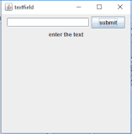

This shows a TextField.

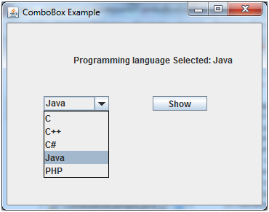

This shows a ComboBox.

Similarly other features mentioned earlier are also implemented.

**JDBC**

Java Database Connectivity is an application programming interface (API) for Java, which defines how a client may access a database.

It is a Java-based data access technology used for Java database connectivity.

The JDBC library includes APIs for each of the tasks mentioned below that are commonly associated with database usage.

* Making a connection to a database.
* Creating SQL or MySQL statements.
* Executing SQL or MySQL queries in the database.
* Viewing & Modifying the resulting records

**MySQL**

MySQL is an open-source relational database management system based on SQL – Structured Query Language.

**Front**-**end**

It refers to the client side or the web design in the web industry. It involves converting data to GUI.

**Database**

It is an organized collection of related data.

A relational database consists of formerly described tables

**DESIGN PHASE**

Software requirements

We have used the following tools to build our mini-project :

1. Eclipse IDE
2. Java development kit.
3. MySQL workbench and server.
4. JDBC

**Flowchart**

**Start**

**Login**

**Reset**

**Enter name,**

**USN**

**No**

**Valid details?**

**IMPLEMENTATION PHASE**

**Yes**

**EXIT**

**Delete records where credits=200**

**Update Student database**

**Calculate the number of credits and add it to the existing credits**

**Retrieve corresponding credits from the subject database**

**Insert details to Student database**

**Retrieve subjects from Subject database**

**Select subjects**

**First semester?**

**Select semester**

**Enter**

**Algorithm**

**Step 1 :** START

**Step 2 :** Create a database with two tables –

* StudentDetails with these fields :
  + Name
  + USN
  + SubjectCode
  + Credits
* Subjects with these fields :
  + SubjectCode
  + SubjectName
  + CreditPerSubject

**Step 4:** Create a Java file that contains the main class. This class will only contain the main method to invoke the required methods.

**Step 5** : Create another class LoginForm which will contain the form.

* Components like [JLabel](https://www.geeksforgeeks.org/jlabel-java-swing/), [JTextField](https://www.geeksforgeeks.org/java-swing-jtextfield/), [ButtonGroup](https://www.geeksforgeeks.org/jradiobutton-java-swing/), [JCheckBox](https://www.geeksforgeeks.org/java-swing-jcombobox-examples/), and [JTextArea](https://www.geeksforgeeks.org/java-swing-jtextarea/). These components will collectively form the Registration form.
* A method **actionPerformed()** to get the action performed by the user and act accordingly.
* Include text fields for USN and Name. Include enter button to proceed. Include Reset button to reset. Include these buttons and text-fields in a container with “Registration Form” as the label .

**Step 6** : Input USN and Name.

**Step 7** : In method actionPerformed(),

On hitting “Enter,

If either field-USN or field-Name or both are empty , then display a message dialog box that says “Enter valid details”.

Else , display an option dialog box with 8 semesters as the options.

On hitting the “Reset” button, go to step 4.

**Step 8** : Select Semester.

If first semester is selected, insert details into the database .Go to step 6.

Else, go to step 7.

(Class –Semester)

**Step 9** : Retrieve subjects from the database.

**Step 10** : Select the subjects via CheckBoxes. Press “Done” button once all the subjects are selected. Select one elective only.

**Step 11** : Retrieve the corresponding credits when the subjects are selected via CheckBoxes.

(Class – CreditCalculate)

**Step 12** : Retrieve the credits from the database and calculate the total number of credits for the selected semester and add it to the existing credits in the database.

(Class- DBUpdate)

**Step 13**: Append the subject codes to the existing subject codes in the database.

**Step 14** : Update the results obtained in steps 10 and 11 to the database . Update the current semester of the student as well. Display a dialog box that has the message “Registration done”.

(Class – DeleteDetails)

**Step 15**: Delete all records from the database where the number of credits is equal to 200.

**Step 16** : END.

* Create classes, objects, constructors , functions , exceptions , Swing components and queries appropriately, as and when necessary .

**RESULTS**

Here are the snapshots of the output under various stages of the project.

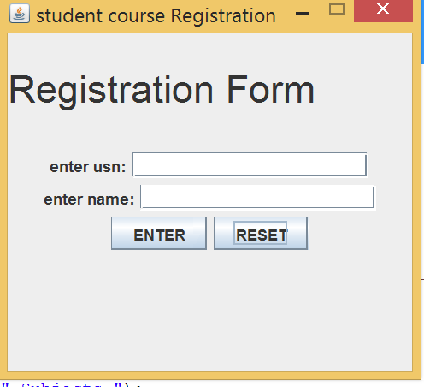

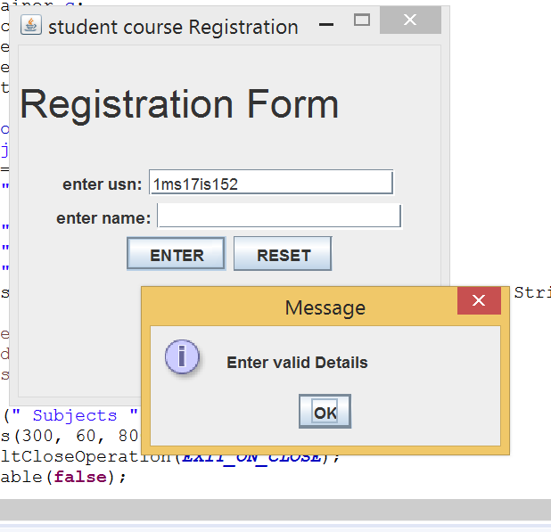

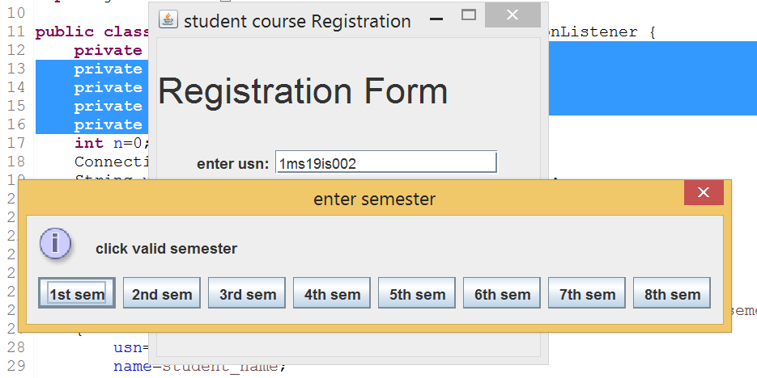

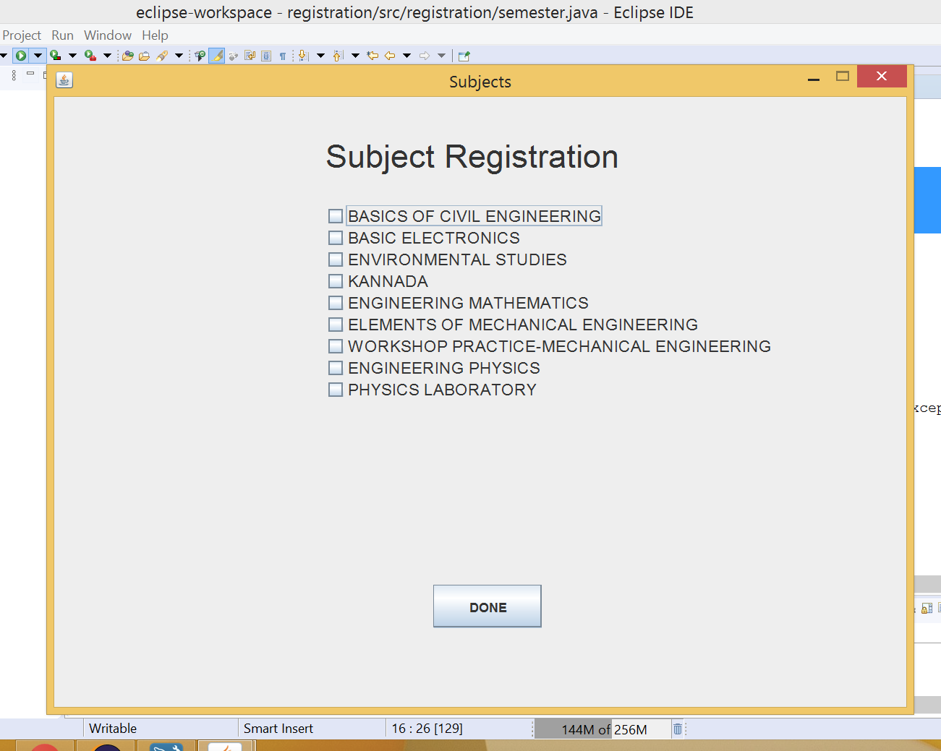

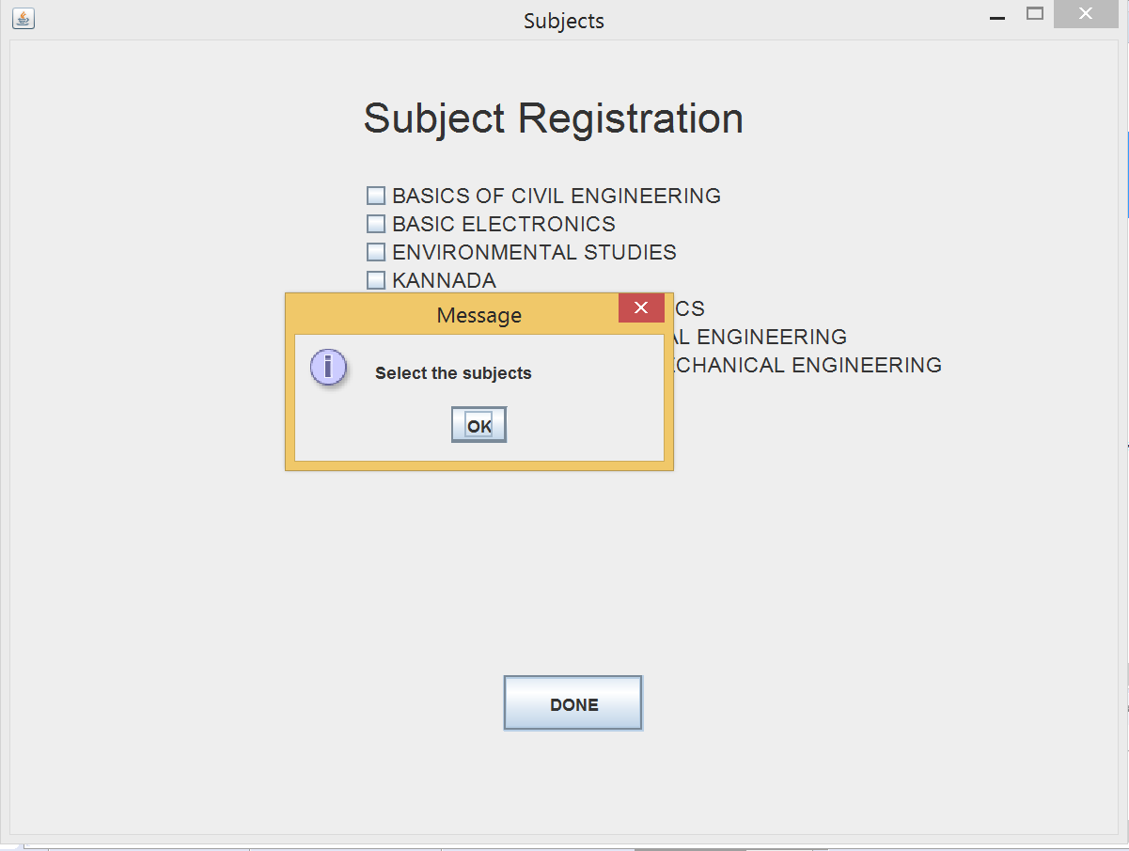

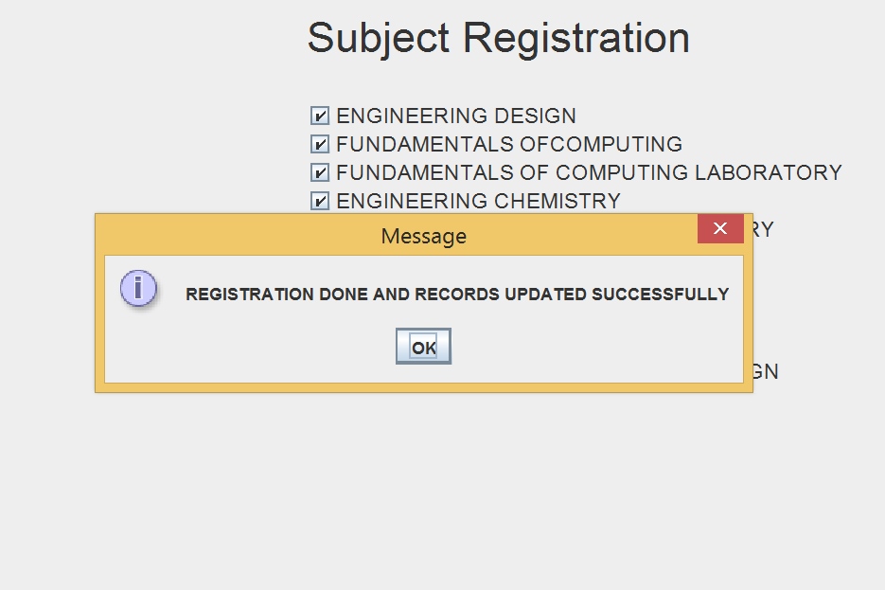

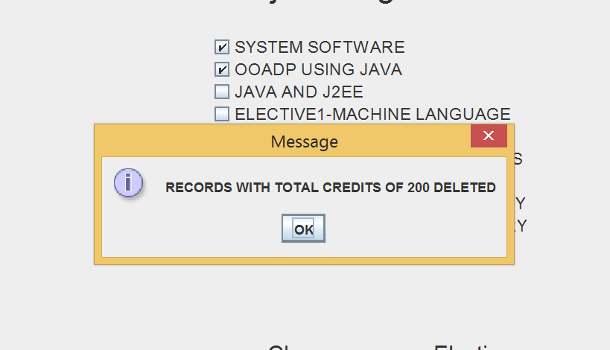

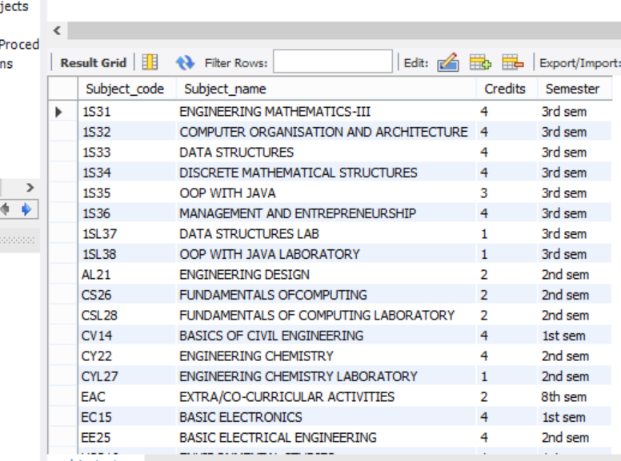

Subject database

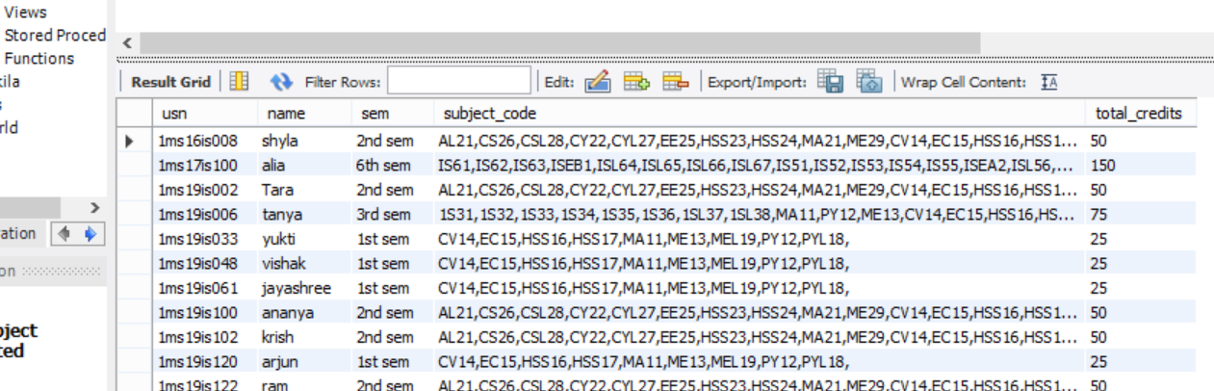

Student database

In conclusion ,we have considered all the requirements specified in the problem statement and built this front-end for a Student course registration form using Java Swings, JDBC and MySQL as the tools.

References :

* Lectures and notes given in the class.
* [www.google.com](http://www.google.com)
* [www.geeksforgeeks.org](http://www.geeksforgeeks.org)

**Thank you ☺**